Uni of York v

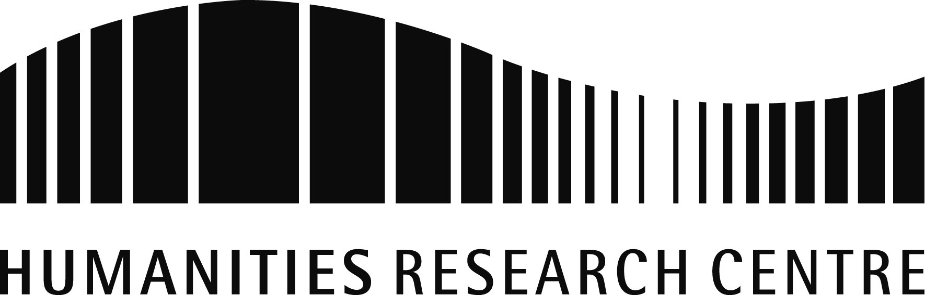

**Living Beyond Theory: Interdisciplinary Perspectives on the Postcolonial**

A two-day symposium hosted by Postcolonial Perspectives in association with the Centre for Modern Studies and the Humanities Research Centre

Thursday 10th - Friday11th February 2011

Berrick Saul Building

**Symposium Programme**

**Thursday, 10th February**

13.15-13.45: Registration (Berrick Saul Building foyer)

13.45-14.00: Introduction (BS/008)

14.00-15.00: **Panel 1** (BS/008)

* Ben Poore (Queen Mary University of London), “Reading Joyce in Lahore: Masud Khan, Modernism, and the Seductions of Psychoanalysis”
* Christin Hoene (University of Edinburgh), “Whose voice? Or: Can the Subaltern Sing? Agency, Identity, and the Raag in Postcolonial Fiction”

15.00-15.30: Coffee break

15.30-16.30: **Panel 2** (BS/008)

* Kirsty Breedon (University of York), “‘Contact Zones’: the Potential of Transcultural Theory for Art History”
* Charlotte Arndt (Humboldt University, Berlin), “Spaces of Negotiation between Postcoloniality and Globalization: African Cultural Magazines in Paris”

16.30-17.30: Group discussion (BS/008)

*Please note that no lunch will be provided on Thursday. After the group discussion, we will go out for a meal to which all participants are welcome: please indicate your interest on your registration form so that we can book accordingly. Participants must fund their own meal, which will be approximately £10-15 before drinks.*

**Friday, 11th February**

9.30-10.00: Registration and Coffee (Berrick Saul Building foyer)

10.00-10.15: Introduction (The Treehouse, 1st floor, BSB)

10.15-11.00: Keynote presentation by Dr. Simon Obendorf (University of Lincoln) (Treehouse)

11.00-12.00: **Panel 1** (Treehouse)

* Gao Gao (University of Edinburgh), “Confucian Between Genders: Female Same Sex Desire in Modern China”
* Denise Wilson (University of Ulster), “Constructing the North: Interpretations of Irish Tourist Images”
* Rebecca Jones (University of Birmingham), “Nigerian Travel Writing, the 'Local' and the Postcolonial”

12.30-13.30: Buffet Lunch (Treehouse)

13.30-15.00:  **Panel 2** (Treehouse)

* Jose Miguel Diaz Rodriguez (University of Leeds), “Living the Postcolonial, Thinking it Neo-colonial, Calling it Cultural Exchange: Spain and the Philippines”
* Emily Baughan (University of Bristol), “‘Empire’s Duty to Europe’s Children:’ Representations of Empire, Internationalism and Humanitarian Responsibility in the Appeals of the Save the Children Fund, 1918-1930”
* Charlotta Salmi (University of Oxford), “Re-writing the Postcolonial Territory: Rifts in Time and Genre”

15.00-15.45: Keynote presentation by Dr. Ruth Craggs, (St Mary’s University College, London) (Treehouse)

15.45-16.15: Coffee break

16.15-17.30: Workshop, chaired by Dr Zoë Norridge (University of York) (Treehouse)

17.30-18.30: Drinks reception

*For registration forms, as well as directions to the university and accommodation information, please visit*

<http://www.york.ac.uk/hrc/events/2010-11/spring/conferences/living-beyond-theory/>

*For all other enquiries, contact the conference committee at*

livingbeyondtheory@events.york.ac.uk